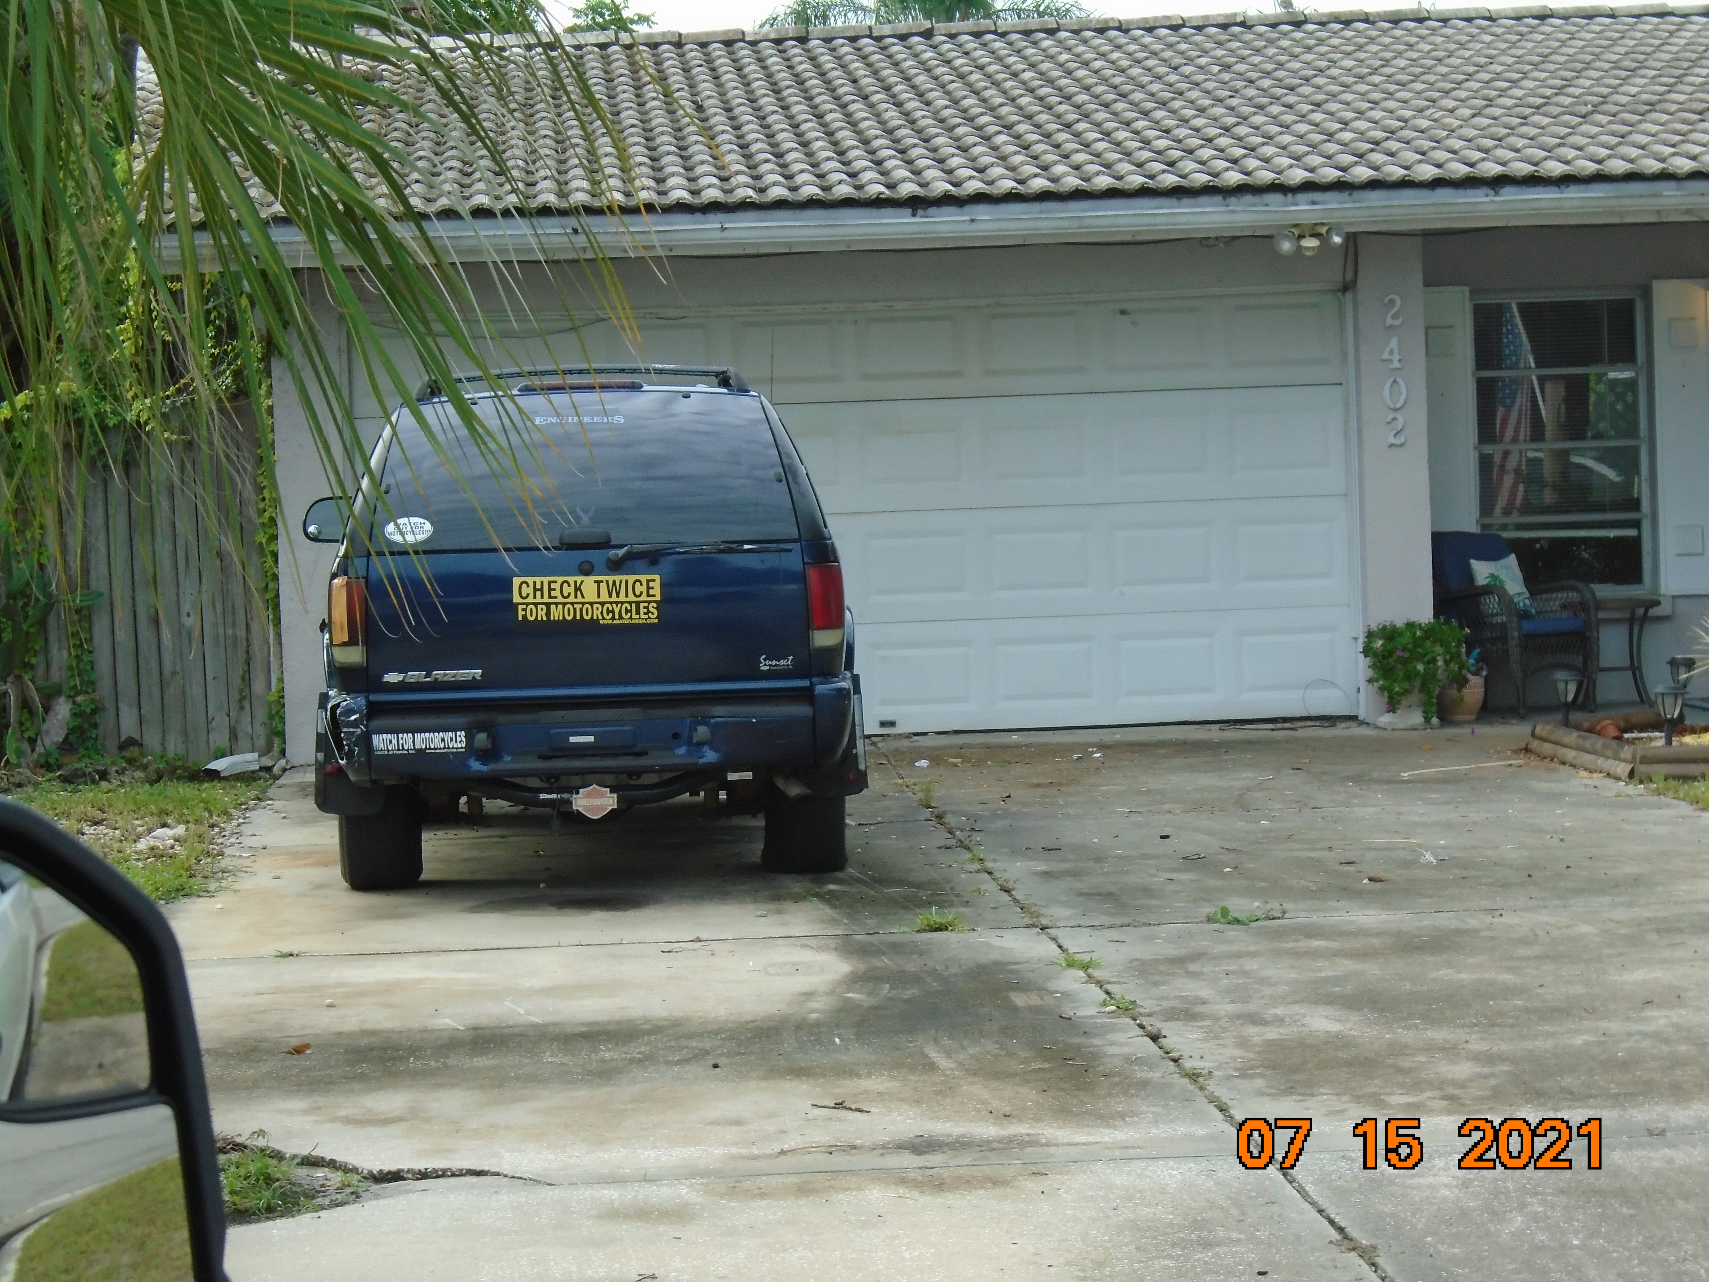
CR-21-1363 2402 CONSTITUTION BLVD. July 15, 2021 JSH

